ITA06 - Machine Learning
List of Lab Exercises

Name: Baranidharan.V
Reg no.: 192312019
Exp 1
Implement and demonstrate the FIND-S algorithm for finding the most specific hypothesis based on a given set of training data samples.
Aim
To implement and demonstrate the FIND-S algorithm to determine the most specific hypothesis from a given set of training examples.
Procedure
- Import the required Python libraries.
- Load the training dataset from a CSV file.
- Separate attributes and target labels.
- Initialize the hypothesis with the first positive example.
- Compare each positive training example with the current hypothesis.
- Generalize the hypothesis whenever attribute values differ.
- Display the final hypothesis.
Program
import pandas as pd
# Create dataset
data = pd.DataFrame({
'Sky': ['Sunny', 'Sunny', 'Rainy', 'Sunny'],
'AirTemp': ['Warm', 'Warm', 'Cold', 'Warm'],
'Humidity': ['Normal', 'High', 'High', 'High'],
'Wind': ['Strong', 'Strong', 'Strong', 'Strong'],
'Water': ['Warm', 'Warm', 'Warm', 'Cool'],
'Forecast': ['Same', 'Same', 'Change', 'Change'],
'EnjoySport': ['Yes', 'Yes', 'No', 'Yes']
})

print("Training Data")
print(data)

concepts = data.iloc[:, :-1].values
target = data.iloc[:, -1].values

hypothesis = concepts[0].copy()

for i in range(len(target)):
if target[i] == "Yes":
for j in range(len(hypothesis)):
if concepts[i][j] != hypothesis[j]:
hypothesis[j] = '?'

print("\nMost Specific Hypothesis:")
print(hypothesis)
Output:
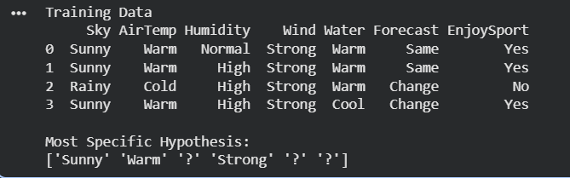
Exp 2:
For a given set of training data examples stored in a .CSV file, implement and demonstrate the Candidate-Elimination algorithm in python to output a description of the set of all hypotheses consistent with the training examples
Aim
To implement the Candidate Elimination algorithm and obtain the version space containing all hypotheses consistent with the training data.
Procedure
- Import required libraries.
- Read the dataset.
- Initialize Specific (S) and General (G) hypotheses.
- Process each training instance.
- Update S and G based on positive and negative examples.
- Display the final S and G boundaries.
Program
import pandas as pd
import numpy as np

data = pd.DataFrame({
'Sky': ['Sunny','Sunny','Rainy','Sunny'],
'AirTemp':['Warm','Warm','Cold','Warm'],
'Humidity':['Normal','High','High','High'],
'Wind':['Strong','Strong','Strong','Strong'],
'Water':['Warm','Warm','Warm','Cool'],
'Forecast':['Same','Same','Change','Change'],
'EnjoySport':['Yes','Yes','No','Yes']
})

concepts = np.array(data.iloc[:,:-1])
target = np.array(data.iloc[:,-1])

specific = concepts[0].copy()
general = [['?' for i in range(len(specific))] for j in range(len(specific))]

for i,h in enumerate(concepts):
if target[i] == 'Yes':
for x in range(len(specific)):
if h[x] != specific[x]:
specific[x]='?'
general[x][x]='?'
else:
for x in range(len(specific)):
if h[x] != specific[x]:
general[x][x]=specific[x]
else:
general[x][x]='?'

print("Specific Hypothesis")
print(specific)

print("\nGeneral Hypothesis")
for g in general:
print(g)

Output:
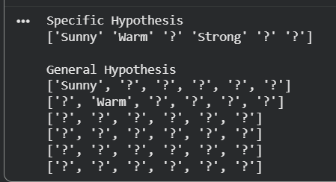

Exp 3:
Demonstrate the working of the decision tree based ID3 algorithm. Use an appropriate data set
for building the decision tree and apply this knowledge to classify a new sample.
Aim
To implement the ID3 Decision Tree algorithm and classify new samples.
Procedure
- Import required libraries.
- Load the dataset.
- Encode categorical variables.
- Split the dataset.
- Train the Decision Tree classifier using entropy.
- Predict test data.
- Display accuracy.
Program
from sklearn.datasets import load_iris
from sklearn.tree import DecisionTreeClassifier
from sklearn.model_selection import train_test_split
from sklearn.metrics import accuracy_score

iris = load_iris()

X_train, X_test, y_train, y_test = train_test_split(
iris.data, iris.target, test_size=0.3, random_state=1)

model = DecisionTreeClassifier(criterion="entropy")
model.fit(X_train, y_train)

prediction = model.predict(X_test)

print("Accuracy =", accuracy_score(y_test, prediction))
Output:
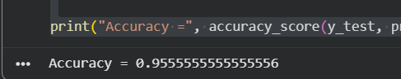

Exp 4:
Build an Artificial Neural Network by implementing the Backpropagation algorithm and test the
same using appropriate data sets.
Aim
To build an Artificial Neural Network using the Backpropagation algorithm.
Procedure
- Import libraries.
- Load dataset.
- Split training and testing data.
- Train MLPClassifier.
- Predict test samples.
- Display accuracy.
Program
from sklearn.datasets import load_iris
from sklearn.neural_network import MLPClassifier
from sklearn.model_selection import train_test_split
from sklearn.metrics import accuracy_score
iris = load_iris()

X_train, X_test, y_train, y_test = train_test_split(
iris.data, iris.target, test_size=0.3, random_state=1)

model = MLPClassifier(hidden_layer_sizes=(10,), max_iter=1000, random_state=1)
model.fit(X_train, y_train)
prediction = model.predict(X_test)
print("Accuracy =", accuracy_score(y_test, prediction))
Output
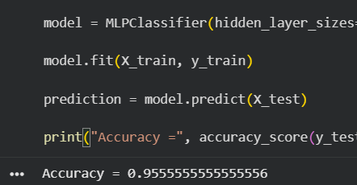
Exp 5:
Write a program for Implementation of K-Nearest Neighbours (K-NN) in Python
Aim
To implement the K-Nearest Neighbour algorithm for classification.
Procedure
- Load dataset.
- Split data.
- Train KNN classifier.
- Predict test samples.
- Calculate accuracy.
Program
from sklearn.datasets import load_iris
from sklearn.neighbors import KNeighborsClassifier
from sklearn.model_selection import train_test_split
from sklearn.metrics import accuracy_score

iris = load_iris()

X_train, X_test, y_train, y_test = train_test_split(
iris.data, iris.target, test_size=0.3, random_state=1)

model = KNeighborsClassifier(n_neighbors=3)

model.fit(X_train, y_train)

prediction = model.predict(X_test)

print("Accuracy =", accuracy_score(y_test, prediction))
Output
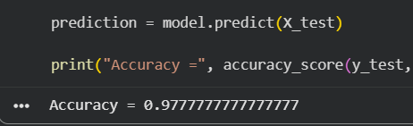

Exp 6:
Write a program to implement Naïve Bayes algorithm in python and to display the results using
confusion matrix and accuracy.
Aim
To implement the Naïve Bayes algorithm and evaluate it using a confusion matrix and accuracy.
Procedure
- Import libraries.
- Load dataset.
- Split dataset.
- Train Gaussian Naïve Bayes model.
- Predict outputs.
- Display confusion matrix and accuracy.
Program
from sklearn.datasets import load_iris
from sklearn.naive_bayes import GaussianNB
from sklearn.model_selection import train_test_split
from sklearn.metrics import confusion_matrix, accuracy_score

iris = load_iris()

X_train, X_test, y_train, y_test = train_test_split(
iris.data, iris.target, test_size=0.3, random_state=1)

model = GaussianNB()

model.fit(X_train, y_train)

prediction = model.predict(X_test)

print("Confusion Matrix")
print(confusion_matrix(y_test, prediction))

print("\nAccuracy =", accuracy_score(y_test, prediction))

Output:
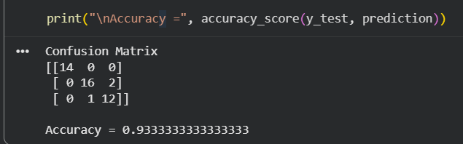

Exp 7:
Write a program to implement Logistic Regression (LR) algorithm in python
Aim
To implement the Logistic Regression algorithm for classification.
Procedure
- Import libraries.
- Load dataset.
- Split training and testing data.
- Train Logistic Regression model.
- Predict outputs.
- Calculate accuracy.
Program
from sklearn.datasets import load_iris
from sklearn.linear_model import LogisticRegression
from sklearn.model_selection import train_test_split
from sklearn.metrics import accuracy_score

iris = load_iris()
X_train, X_test, y_train, y_test = train_test_split(
iris.data, iris.target, test_size=0.3, random_state=1)

model = LogisticRegression(max_iter=200)
model.fit(X_train, y_train)

prediction = model.predict(X_test)

print("Accuracy =", accuracy_score(y_test, prediction))
Output
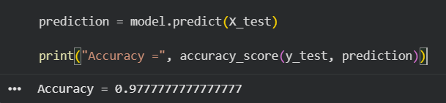
Exp 8:
Write a program to implement Linear Regression (LR) algorithm in python
Aim
To implement the Linear Regression algorithm and predict continuous values.
Procedure
- Import libraries.
- Load dataset.
- Split data.
- Train Linear Regression model.
- Predict outputs.
- Compute Mean Squared Error and R² score.
Program
from sklearn.datasets import fetch_california_housing
from sklearn.linear_model import LinearRegression
from sklearn.model_selection import train_test_split
from sklearn.metrics import mean_squared_error, r2_score

housing = fetch_california_housing()

X_train, X_test, y_train, y_test = train_test_split(
housing.data, housing.target, test_size=0.3, random_state=1)

model = LinearRegression()

model.fit(X_train, y_train)

prediction = model.predict(X_test)

print("Mean Squared Error =", mean_squared_error(y_test, prediction))
print("R2 Score =", r2_score(y_test, prediction))
Output:
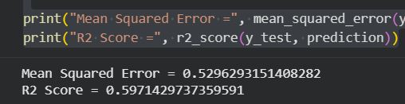
Exp 9:
Compare Linear and Polynomial Regression using Python
Aim
To implement and compare Linear Regression and Polynomial Regression using Python.
Procedure
- Import the required libraries.
- Load the dataset.
- Split the dataset into training and testing sets.
- Train the Linear Regression model.
- Transform the features into polynomial features.
- Train the Polynomial Regression model.
- Compare both models using the R² score.
- Display the results.
Program
import numpy as np
import matplotlib.pyplot as plt
from sklearn.preprocessing import PolynomialFeatures
from sklearn.linear_model import LinearRegression
from sklearn.metrics import r2_score

# Sample Dataset
X = np.array([1,2,3,4,5,6,7,8,9,10]).reshape(-1,1)
y = np.array([1.2,1.9,3.2,3.9,5.1,6.8,8.5,10.3,12.8,15.6])

# Linear Regression
linear = LinearRegression()
linear.fit(X,y)
y_linear = linear.predict(X)

# Polynomial Regression
poly = PolynomialFeatures(degree=2)
X_poly = poly.fit_transform(X)

poly_model = LinearRegression()
poly_model.fit(X_poly,y)
y_poly = poly_model.predict(X_poly)

print("Linear Regression R2 Score:", r2_score(y,y_linear))
print("Polynomial Regression R2 Score:", r2_score(y,y_poly))

plt.scatter(X,y,color='red',label='Data')

plt.plot(X,y_linear,color='blue',label='Linear Regression')

plt.plot(X,y_poly,color='green',label='Polynomial Regression')

plt.xlabel("X")
plt.ylabel("Y")
plt.title("Linear vs Polynomial Regression")
plt.legend()
plt.show()
Output
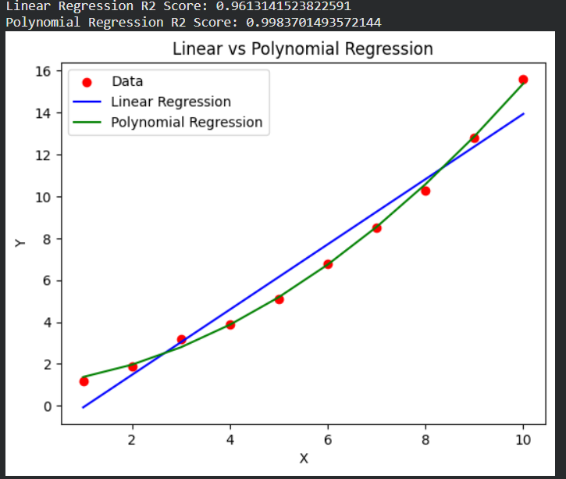

Exp 10:
Write a Python Program to Implement Expectation & Maximization Algorithm
Aim
To implement the Expectation Maximization (EM) algorithm using Gaussian Mixture Model (GMM) in Python.
Procedure
- Import the required libraries.
- Create a sample dataset.
- Apply the Gaussian Mixture Model.
- Fit the EM algorithm to the dataset.
- Predict the cluster labels.
- Display the clustered data.
Program
import numpy as np
import matplotlib.pyplot as plt
from sklearn.mixture import GaussianMixture

# Sample Dataset
X = np.array([[1,2],
[2,1],
[3,2],
[8,8],
[9,10],
[10,9],
[11,10]])

# Apply EM Algorithm
gmm = GaussianMixture(n_components=2, random_state=42)

gmm.fit(X)

labels = gmm.predict(X)

print("Cluster Labels:")
print(labels)

plt.scatter(X[:,0], X[:,1], c=labels, cmap='viridis', s=100)

plt.title("Expectation Maximization Clustering")
plt.xlabel("X")
plt.ylabel("Y")
plt.show()
Output
